Parish Priest: Fr Alexander Ibe SMMM email: parishpriestnorthbedford@gmail.com
Parish Secretary HC: Sheila Allen email: parish.holycross@northamptondiocese.org
Parish Secretary PJ: Mariateresa Quinlan email: parish.ssphilipandjames@northamptondiocese.org

Website: https://northbedfordcatholics.org.uk/
Facebook: @holycrossbedford

Dear Parishioner

Welcome to North Bedford Catholic Community
(the Parishes of Holy Cross and Saints Philip & James)

We hope you settle in well and soon feel a part of the parish community. You may already have discovered our website with information about Mass times, Confessions, groups and societies, news and events that make up our thriving community.
However, you may appreciate having this information sheet to stick on your fridge door with the basic details to hand so that you don’t have to go searching for them, or wonder where you put the newsletter!

MASS TIMES
Any changes to these times (due to funerals, etc.) will be in the weekly newsletter.
 | Holy Cross Church | Ss Philip & James Church
Monday |  | 10:15am Liturgy of the Word & Holy Communion
Tuesday | 10:15am
Wednesday | 10:15am  (followed by the Sacrament of Confession & Eucharistic Adoration to 11.15am)
Thursday |  | 10:15am
Friday | 10:15am
Saturday | 5:30pm (Vigil Mass) | 10:15am  (followed by the Sacrament of Confession & Eucharistic Adoration to 11.30am)
Sunday | 9:00am | 11:00am

If you would like more information, please contact us using the details at the top of this page.

God bless.
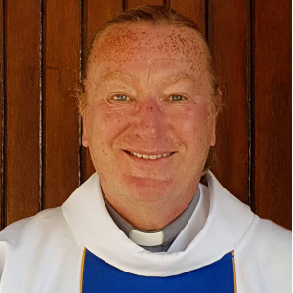
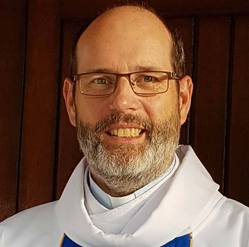
Fr Alexander Ibe SMMM, Parish Priest
Deacon Tony Quinlan
Deacon Crispin Walkling-Lea

Welcome to Holy Cross Church and Saints Philip & James Church!
We would be grateful if you could complete and return this form.* Thank you.

Date of arrival in the parish:

Title: | Name:
Address:
Telephone number:
Email address:
We may contact you from time to time with details of parish news and events.
How would you prefer to be contacted?

Post Email Telephone Not at all

Do you have family members who come to church with you?
Spouse | Name:
Children | Name: | Date of birth:
Other family members | Name: | Relation to you:

* We will hold your details for the purposes of information and communication within North Bedford Catholic Community. We will not pass on your details to any third party.

Would you like a phone call in a few weeks, to see how you’re settling in?

Yes, please. No, thank you.

Do you have special needs that we need to know about?

Yes, I do. No, I don’t.

If ‘Yes’ then please provide relevant details:

Is there anything else you would like to know or any groups that you might be interested in joining?

Please return this form to either:
Sheila Allen, Parish Secretary, Holy Cross Church, at the above address, or
Mariateresa Quinlan, Parish Secretary, Saints Philip & James Church, at the above address. Thank you.

